Manual Unit Testing – Individual Enhancement

Twitter Button:

1. Once in any of the three data views, click on the Twitter Button in the bottom left corner of the page.

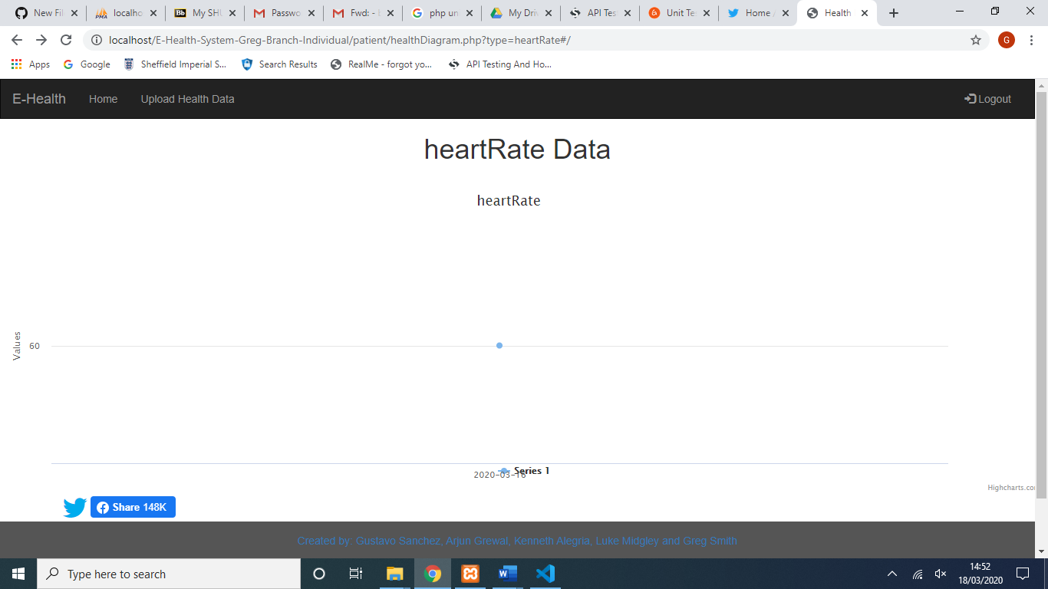

1. This automatically takes you to the create a new tweet page on Twitter, the Post field is automatically populated with the data type and all the latest weeks data.

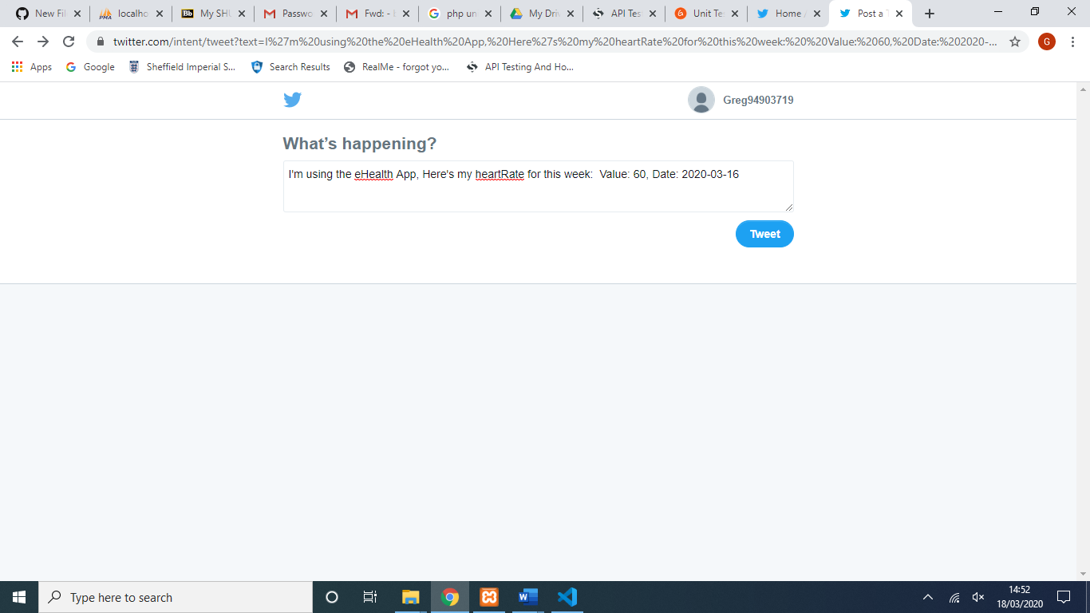

1. 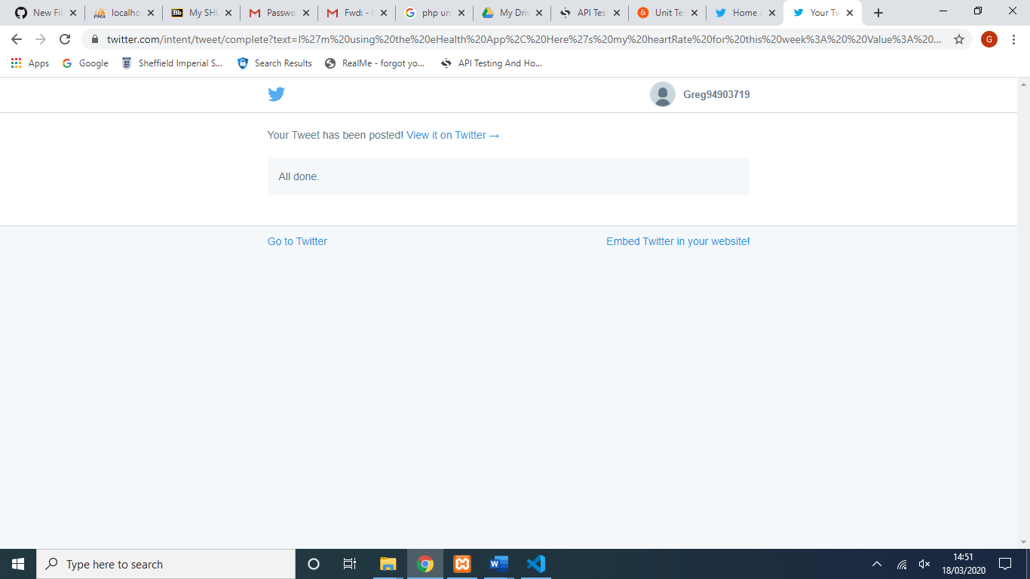after clicking ‘Tweet’, a conformation pops up confirming the tweet has been posted to the account currently logged on.
2. 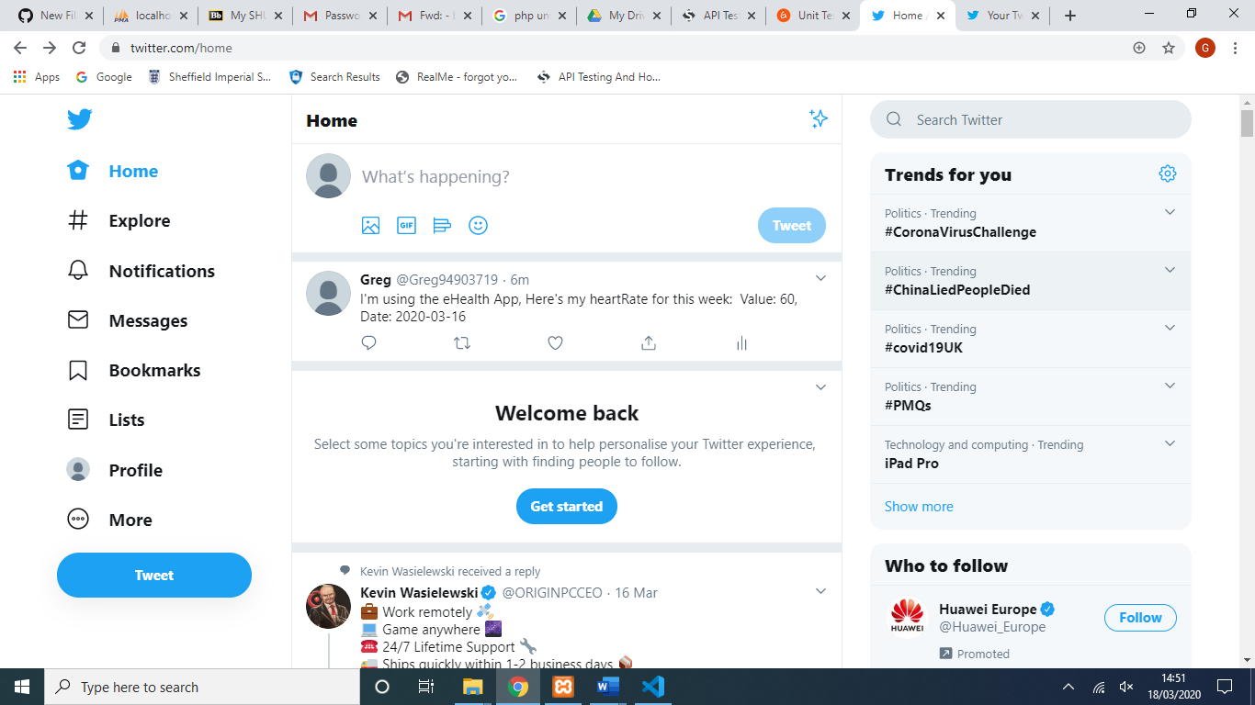Lastly, to ensure the tweet has been posted the home page is viewed.

Facebook Button:

1. Same as for the Twitter Button, click the share button in the bottom left corner of the screen.



1. This automatically takes you to the ‘Post to Facebook’ page on Facebook. The post contains the placeholder link as explained in the readme file.

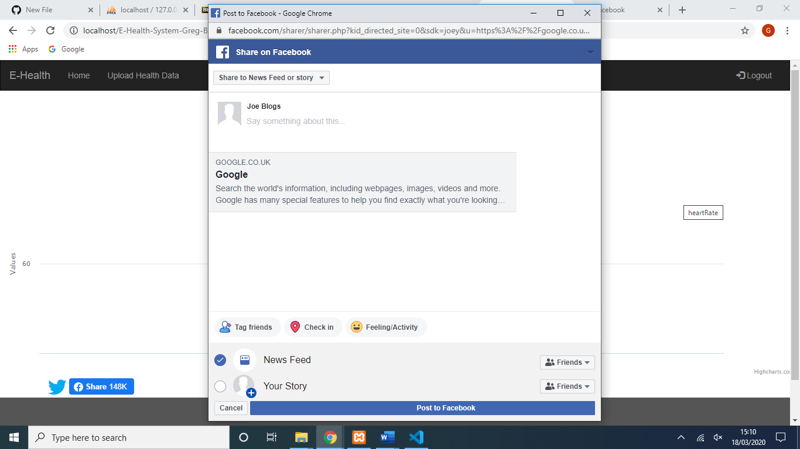

1. 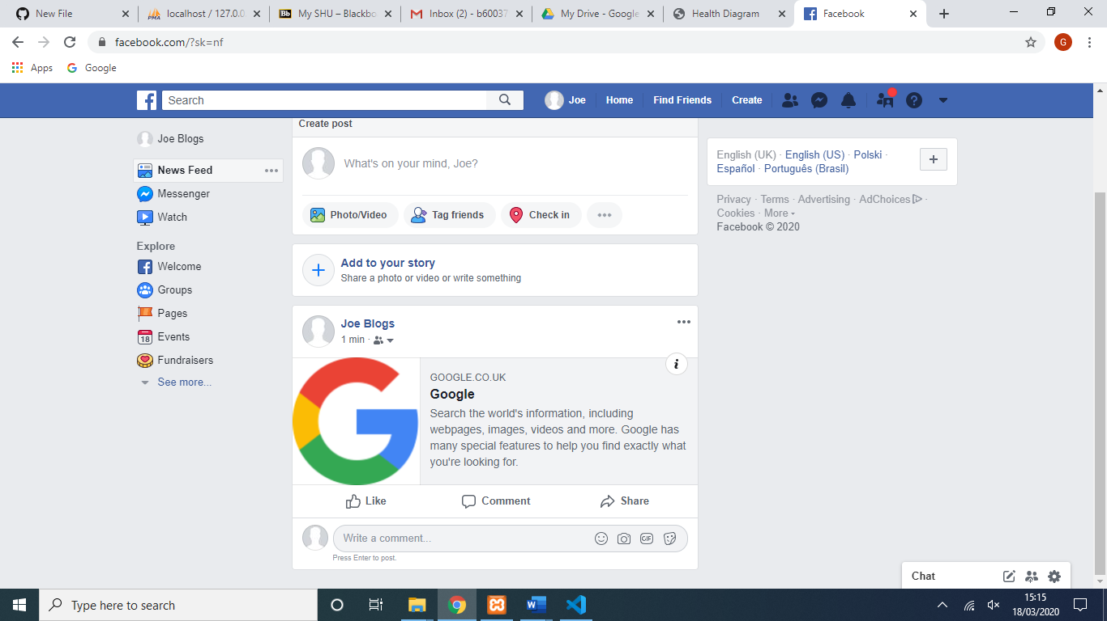After clicking Post to Facebook, the users News feed is checked to ensure the post has been made.